1.Login

Action: Login with incorrect username and password.

Steps:

Expected Results: “Incorrect Email or Password” message pops up.

|  |
| --- |
|  |

Pass/Fail: Pass

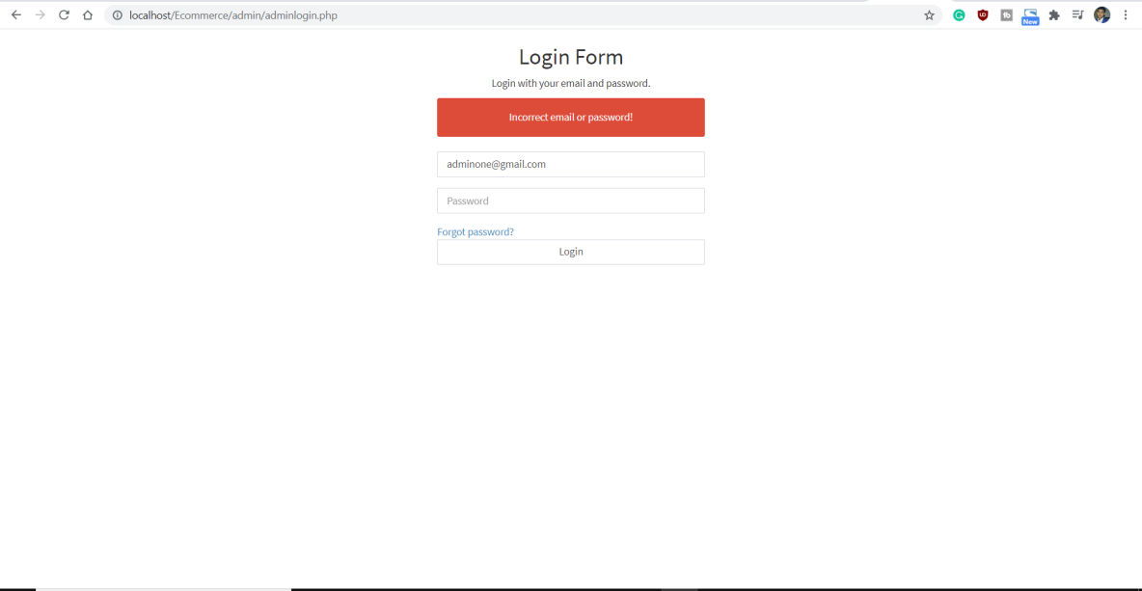

Action: Login with correct username and password.

Steps:

Expected Results: You get into the dashboard page.

Pass/Fail: Pass

|  |
| --- |
|  |

Action: When clicking on shops

Steps:

Expected Results: You can see the shop list

Pass/Fail: Pass

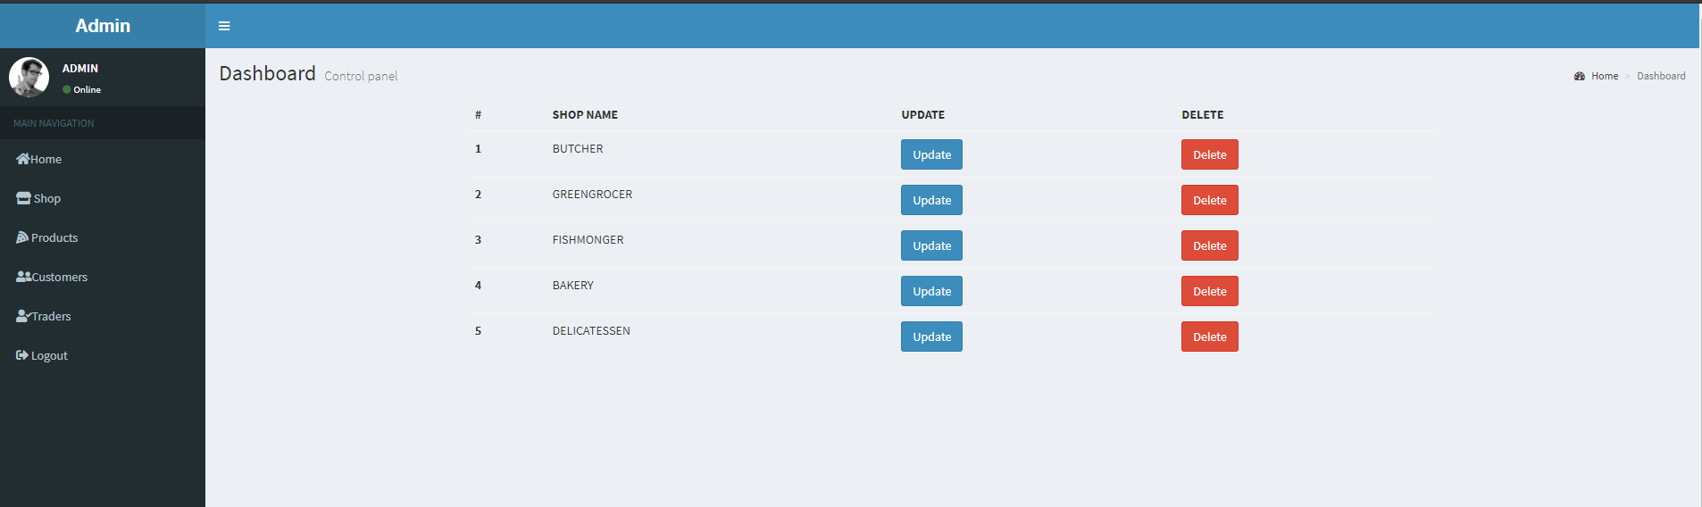

Action: When clicking on products

Steps:

Expected Results: You can see the products

Pass/Fail: Pass

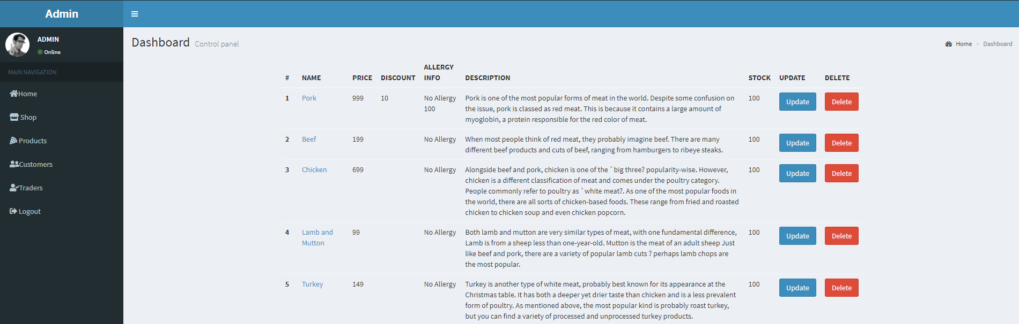

Action: When clicking on Update Products

Steps: Click on Update

Expected Results: You can Update and edit Products

Pass/Fail: Pass

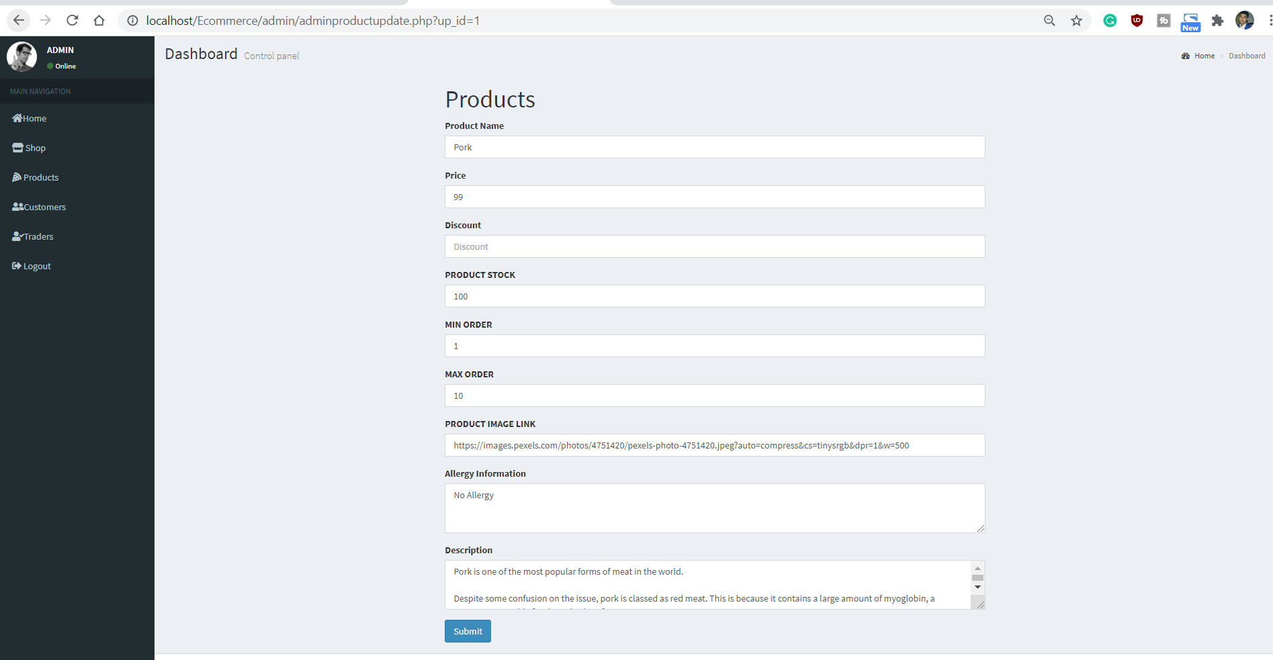

Action: When Clicking on Delete Products

Steps: Click on Delete

Expected Results: A product is deleted

Pass/Fail: Pass



Action: When clicking on Customers

Steps: Click on Customer

Expected Results: It will display details of Customers

Pass/Fail: Pass

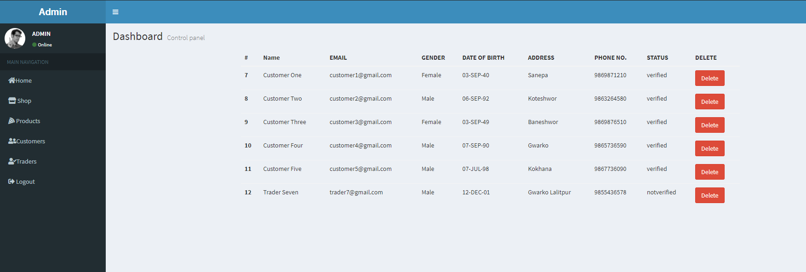

Action: When clicked on Delete

Steps: Click on Delete

Expected Results: Customer is deleted

Pass/Fail: Pass

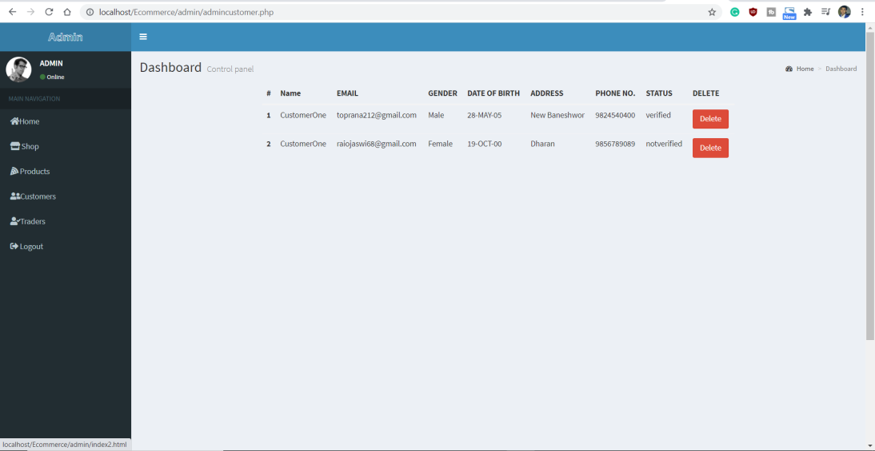

Action: When clicked on Traders

Steps: Click on Traders

Expected Results: Traders list will be displayed

Pass/Fail: Pass

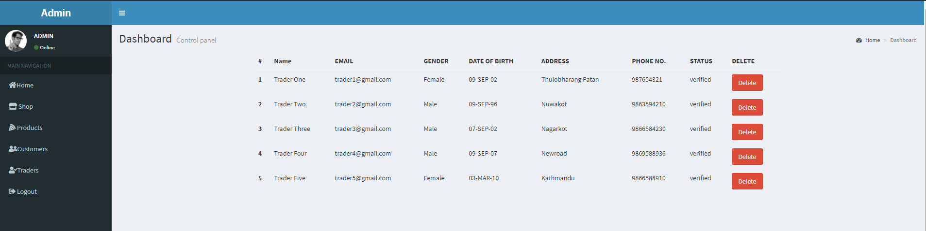

Action: When clicked on Delete

Steps: Click on Delete

Expected Results: Trader’s data will be deleted

Pass/Fail: Pass



Action: When clicked on logout

Steps: Click on Logout

Expected Results: You can logout from the page.

Pass/Fail: Pass

